Ta Quang Tung – 104222196

COS20019 – Cloud Computing Architecture - Wk7: ACF Lab 6: Scaling and Load Balance your architecture

**Task 1 - Create an AMI for Auto Scaling**



Steps 5-8: After waiting for Web Server 1 to pass both status checks, create an AMI from it.



Step 9: Configure a name and description for the AMI.

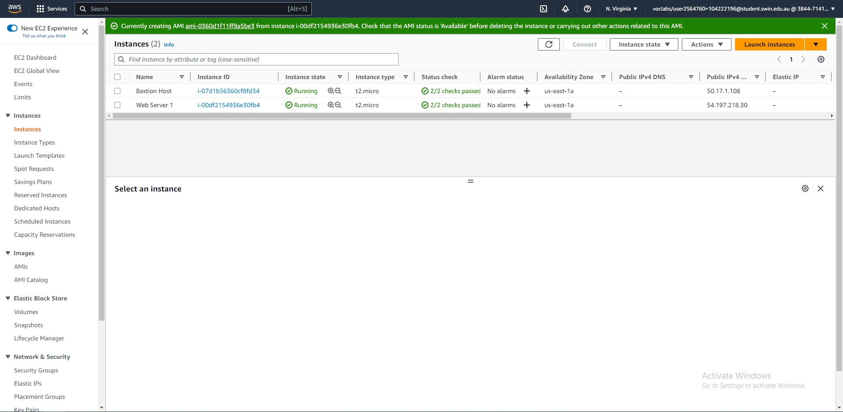



Step 10: The AMI is being created.

**Task 2 - Create a Load Balancer**



Step 11: Create a target group – Choose target type of Instances.



Step 11: Create a target group – Enter the group name of LabGroup and select the Lab VPC.



Steps 12-13: The target group has been created.



Steps 14-17: Create an Application Load Balancer – Enter the name LabELB.



Step 18: Create an Application Load Balancer – Under network mapping, choose the Lab VPC and the two public subnets.



Steps 19-20: Create an Application Load Balancer – Assign only the Web Security Group and set the default action to forward to LabGroup.



Step 21: The load balancer has been created.

**



Steps 22-24: Create a launch template – Set the name to LabConfig and enable Provide Guidance.



Step 24: Create a launch template – Choose the Web Server AMI and instance type t2.micro.



Step 24: Create a launch instance – Choose vockey and assign the Web Security group.



Step 24: Create a launch template – Enable detailed CloudWatch monitoring.



Steps 25-27: Create an Auto Scaling group - Step 1 – Enter a group name and select the LabConfig as the launch template.



Step 28: Create an Auto Scaling group – Step 2 – Choose the Lab VPC and private subnets 1 and 2 to launch new instances in.



Step 29 – Create an Auto Scaling group – Step 3 – Attach the group to an existing load balancer, set the target group to LabGroup and enable group metrics collection within CloudWatch.



Step 30 – Create an Auto Scaling group – Step 4 – Configure the group size and scaling policies.

Step 31 – Create an Auto Scaling group – Step 5 – Leave as default.



Step 32 – Create an Auto Scaling group – Step 6 – Add a name tag which will be applied to all instances.

Step 33 – Create an Auto Scaling group – Review.



Step 33: The scaling group has been created successfully.

**Task 4: Verify that Load Balancing is Working**



Step 44: Two Lab Instances have been launched by Auto Scaling.



Steps 45-48: The “Targets” tab of the LabGroup target group shows two healthy Lab Instances launched by Auto Scaling.



Steps 49-51: Copy the DNS name of the LabELB load balancer.



Step 52: Open the DNS name in a new tab. The request was sent to an EC2 instance.

**Task 5 - Test Auto Scaling**



Steps 52-55: CloudWatch shows two alarms, one of which is OK.



Steps 56-57: Choose Load Test in the web application to generate a high load.



Steps 58-59: After creating the load, AlarmLow changes to OK and AlarmHigh changes to In alarm. CPU utilization is over 60%.



Steps 60-61: More Lab Instances have been launched by Auto Scaling to accommodate the increased CPU usage.

**Task 6 - Terminate Web Server 1**



Steps 62-64: Successfully terminated Web Server 1.